
CSA05-DATABASE MANAGEMENT SYSTEMS
LAB MANUAL
DDL Commands – CREATE, ALTER, DROP
AIM:
To Create, Alter, Drop, Rename, Truncate using Data Definition Language (DDL) statements. Description:
Data Definition Language (DDL) statements are used to define the database structure or schema. DDL Commands: Create, Alter, Drop, Rename, Truncate
➢ CREATE - to create objects in the database
➢ ALTER - alters the structure of the database
➢ DROP - delete objects from the database
➢ TRUNCATE - remove all records from a table, including all spaces allocated for the records are removed
➢ RENAME - rename an object

COMMANDS
1. Create Database
CREATE DATABASE MobileDB;

2. Select Database
USE MobileDB;
3.Create Table
CREATE TABLE MobileSales
(
MobileName VARCHAR(20),
Price INT,
CustomerReview DECIMAL(2,1),
UnitsSaled INT,
ModelYear INT,
Storage INT
);

4. Display Table Structure
DESC MobileSales;
5. Insert Records
INSERT INTO MobileSales
VALUES
('OnePlus14R',25000,4.0,10000,2025,128),
('Redmi12',20000,4.0,10000,2024,128),
('SamsungS10',30000,4.1,5000,2023,256),
('iPhone12',45000,3.9,4000,2024,128),
('MotoG36',21000,4.0,2000,2025,128),
('Pixel6A',30000,4.5,5000,2024,256),
('iPhone14',49000,4.0,5500,2025,128),
('IQZ6',25000,4.2,7000,2025,256),
('OnePlusCE5',29000,4.4,2000,2026,256),
('iPhone15',70000,4.0,2000,2026,128);
6. Display Records
SELECT * FROM MobileSales;

7. Add a New Column
ALTER TABLE MobileSales
ADD Color VARCHAR(20);
8. Verify Table Structure
DESC MobileSales;
9. Drop the Added Column
ALTER TABLE MobileSales
DROP COLUMN Color;
10.Verify Table Structure
DESC MobileSales;
11. Rename the Table
ALTER TABLE MobileSales
RENAME TO MobileSalesDetails;
12.Display Table
SHOW tables;
13. Rename the Table Back
ALTER TABLE MobileSalesDetails
RENAME TO MobileSales;
14. Display Available Tables
SHOW TABLES;
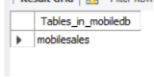
OUTPUTS
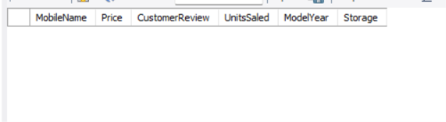
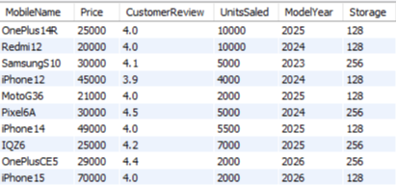
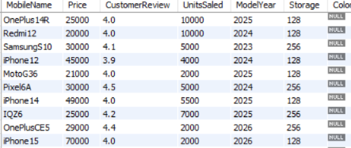

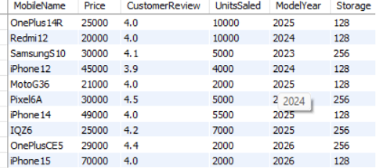
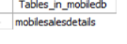



RESULT
Thus, the DDL commands (CREATE, ALTER, RENAME and DROP COLUMN) were executed successfully on the MobileSales table.

DDL Commands with Constraints – PRIMARY KEY, UNIQUE, CHECK

AIM
To add constraints like Primary Key, Unique Key and Check using DDL commands.
PROCEDURE
- Select the required database using the USE command.
- Create a new table named MobileSales_Constraint with the required columns.
- Define the PRIMARY KEY constraint for the MobileName column.
- Define the UNIQUE constraint for the Price column.
- Define the CHECK constraint to ensure the CustomerReview values are between 1 and 5.
- Define the CHECK constraint to allow the ModelYear values only between 2023 and 2026.
- Define the CHECK constraint to allow only 128 GB and 256 GB values in the Storage column.
- Execute the CREATE TABLE statement successfully.
- Display the table structure using the DESC command to verify the constraints.

COMMANDS

1. Add PRIMARY KEY Constraint on MobileName
ALTER TABLE MobileSales
ADD CONSTRAINT PK_Mobile
PRIMARY KEY (MobileName);

2. Verify the Table Structure
DESC MobileSales;

3. Add UNIQUE Constraint on Price
ALTER TABLE MobileSales
ADD CONSTRAINT UQ_Price
UNIQUE (Price);

4. Add CHECK Constraint for CustomerReview
ALTER TABLE MobileSales
ADD CONSTRAINT CHK_Review
CHECK (CustomerReview BETWEEN 1 AND 5);

5. Add CHECK Constraint for Storage
ALTER TABLE MobileSales
ADD CONSTRAINT CHK_Storage
CHECK (Storage IN (128,256));

6. Display Table Structure
DESC MobileSales;

OUTPUTS

